3-4 Alyssa’s Guest List
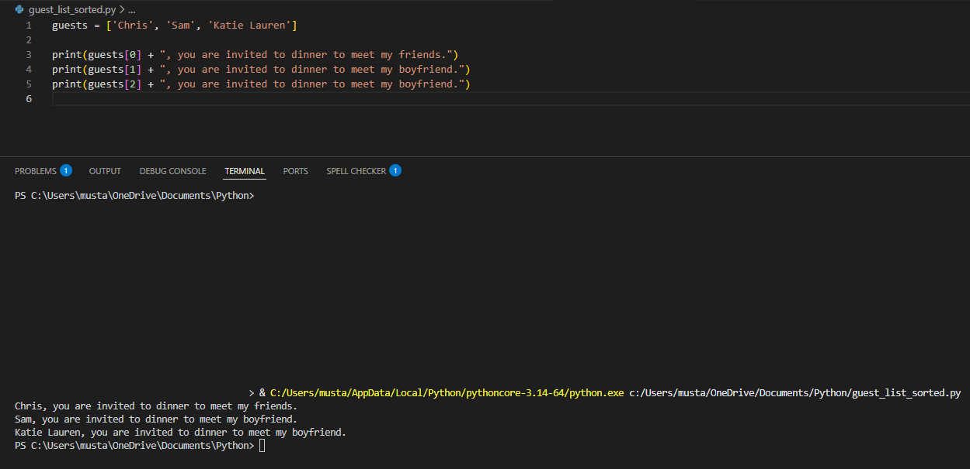

3-8 Alyssa’s Updated Guest List
